**Ben Guthrie – Lac du Flambeau Public Library**

PO Box 729, 622 Peace Pipe Rd., Lac du Flambeau, WI 54538 Phone: (715) 588-7001 Fax: (715) 588-7101

**Hours of Operation:**

Mon – Thur 9:30 am – 5:00pm

Fri 9:30am – 4:30pm

Saturday 10:00 am – 2:00 pm

Closed Sunday and Holidays

Basic Computer Skills

Please come anytime during normal operation hours.

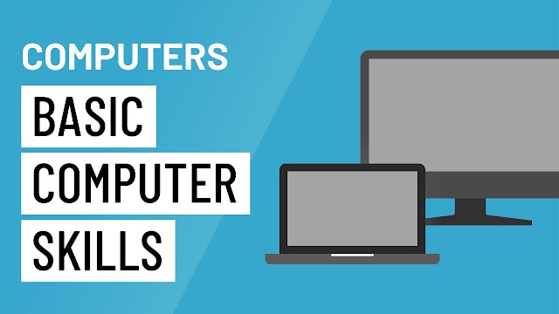

**Teach yourself basics of:**

**Video Conferencing**

**Intro to Facebook**

**Basic Search**

**Navigating a Website**

**Getting Started on a Computer**

**Intro to Email**

**Intro to Email 2: Beyond the Basics**

**Using a PC (Windows 10)**

**Accounts & Passwords**

**Online Fraud and Scams**

**Creating Resumes**

**Online Job Search**

**Microsoft Word**

**Online Health Information**

**Public Computers with Internet Access.**

**Learn at your own pace and convenience.**

**Staff on hand for any questions or guidance.**

**Open to the Public Starting May 13th**